MED D - Incomplete Enrollments (ICE) or Enrollments with Missing Information

Overview
Who is Authorized to Provide Missing Information for Incomplete Enrollments
Resolving Incomplete Enrollments or Enrollments with Missing Information
Resolution Time
Related Documents

Description: This document provides the processes a CCR needs to assist a beneficiary in completing an enrollment application marked incomplete or missing information.

Overview
All faxed, paper, and phone MED D enrollment applications are submitted to the Beneficiary Eligibility Query (BEQ) for processing in FAZAL. When information is missing or determined to be invalid on the enrollment application, the application will fall out as incomplete.

When a beneficiary calls with any information regarding an incomplete enrollment application, the MED D Customer Care Representative (CCR) will:
- Verify that the enrollment is incomplete in FAZAL.
- Obtain the missing information.
- Document the information accordingly in the Customer Service Notes field in FAZAL.

Beneficiary Services will then update the incomplete application and submit the enrollment to CMS.

This document will assist the CCR in resolving incomplete enrollments by allowing the CCR to add the missing information needed to complete the application and adhere to CMS guidance, current policies and procedures.

Top of the Document

Who is Authorized to Provide Missing Information for Incomplete Enrollments
Any third party callers (benefits offices, prescribers, sales agents, and/or individuals calling on behalf of the beneficiary, etc.) are NOT authorized to provide missing information for incomplete enrollments for MED D beneficiaries.

Missing information for incomplete enrollments can only be made by the following individuals:
- The beneficiary
- Authenticated SHIP Counselor
  - Refer to the MED D - SHIP Counselor Calls For Part D Plans work instruction.
- Designated individuals with Power of Attorney (POA) or legal representative documentation
Refer to the MED D - Appointed Representative Form (AOR) or Power of Attorney (POA) and MED D - Obtaining a Verbal Attestation from an Authorized Representative.

Top of the Document

Resolving Incomplete Enrollments or Enrollments with Missing Information

To resolve enrollment applications marked incomplete or with missing information, the CCR will:
Step | Action
1 | Authenticate the caller.  Refer to the following documents:  - Caller Authentication  - HIPAA Authentication Grid  Note: If caller verbally attests to being the beneficiary or AOR/POA, continue to assist with updating incomplete enrollment  - As the authorized representative, are you authorized under State law to complete the enrollment and is documentation of this authority available upon request?  - Advise caller they must submit legal documentation and document PeopleSafe with name, address and phone number of the caller. Documentation can be submitted to:  SilverScript Insurance  P.O. Box 30001  Pittsburgh, PA 15222-0330  Fax: 1-866-552-6205  Phone: 1-833-606-0372  Blue MedicareRx  P.O. Box 30001  Pittsburgh, PA 15222  Fax: 1-866 342-7048
2 | Log into FAZAL.  Refer to the Logging into FAZAL section of the MED D Enrollment - FAZAL work instruction.
3 | - Search for the enrollee’s enrollment information in FAZAL.  - Verify the beneficiary’s enrollment status in the Record Stage column.  - Refer to the Searching for Enrollment Information in FAZAL section of the MED D Enrollment - FAZAL work instruction.
3 | If the Record Stage is… |  | Then…
3 | Incomplete Q |  | Click on the Subscriber ID to open the enrollee’s enrollment application.  Proceed to the next step.
3 | Anything else |  | Refer to the Searching for Enrollment Information in FAZAL section of the MED D Enrollment - FAZAL work instruction.
4 | View all sections (1, 2, and 3) of the enrollment application and review any and all comments on Section 3 in Comments field to determine what information is missing or incomplete.  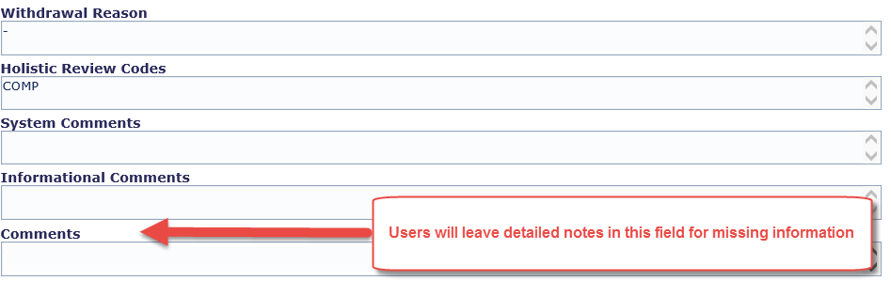  The most common information that is missing or incomplete is:  - Valid MBI  - Permanent Address (only authorized exceptions allowed for PO Boxes)  - Reason for SEP or missing SEP event date (Not applicable for EGWPs)  - Refer to the MED D - Election Periods for Enrollment and Disenrollment (AEP, IEP, SEP) job aid.  NEJE CCRs Only: NEJE CCR will need to receive Supervisor or NEJE dedicated Senior approval.  Important: The CCR must review the entire application to ensure all missing information is captured.  - Not all incomplete information will be highlighted PINK or identified in the Comments field.
5 | Verify if the Customer Service Notes field is available to enter documentation.
5 | If the Customer Service Notes field is… |  | Then…
5 | Available |  | Proceed to Step 6.
5 | Not available (grayed out) |  | Proceed to Step 9.
6 | Document the new or updated information needed to complete the application  - Select Additional Information Required in the CSR Category drop down menu.  - Enter the appropriate notes in the Customer Service Notes field of the Section 3 screen using the table below.  Important: Copy the Documentation Note (italicized) exactly as listed in the table below for each missing piece of information and complete with details provided by the beneficiary.  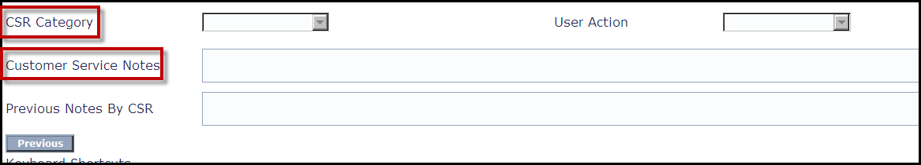  Note: Information can be entered into the Customer Service Notes field only while the enrollment application is marked incomplete.  CCR Process Note: Only beneficiaries and designated individuals with POA or AOR/Legal Representative documentation can provide missing information to complete a beneficiary’s enrollment application to a MED D prescription drug benefit plan.  - Refer to the Who is Authorized to Provide Missing Information for Incomplete Enrollments section of this work instruction.  Proceed to Step 7.
6 | Missing/Incomplete Information |  |  | Documentation Note
6 | Valid MBI |  |  | The beneficiary provided <####> as his/her MBI.  - The MBI was verified in MARx  OR  - MBI not yet available in MARx.  Note: Refer to the MED D - Verifying Enrollment, Eligibility and LIS in MARx work instruction  CCR Process Note: If the MBI is not available in MARx, advise the beneficiary to send a copy of his/her Medicare card or award letter to:  SilverScript Insurance Company  PO Box 30001  Pittsburgh, PA 15222-0330  FAX: 1-866-552-6205  Blue MedicareRx  P.O. Box 30001  Pittsburgh, PA 15222  Fax: 1-866 342-7048
6 | Permanent Address |  |  | - The beneficiary has provided <Address> as the permanent physical address.  OR  - The beneficiary has verbally attested that s/he resides in the plan’s coverage area and only wants to provide a P.O. Box.  Note: Make sure to include this information in the CSR notes to ensure that the record is able to be resolved successfully.  CCR Process Note: The beneficiary must provide a valid physical Permanent Address or a Verbal Attestation that s/he resides in the coverage area and only wishes to provide a P.O. Box except as indicated below.  - EGWP Coverage Area = All 50 states and Puerto Rico and Washington D.C.  - Individual Plan Coverage Area = CMS region(s).  Verbal Attestation Exceptions: Certain clients have specific rules regarding verbal attestations.  - State of Hawaii EUTF and PACE: Provides verbal attestation for all beneficiaries  - The CCR does not need to obtain a verbal attestation from beneficiaries with a P.O. Box address.
6 | Reason for SEP  (Not applicable for EGWPs) |  |  | - The beneficiary has provided <SEP Name>.  - Qualified on <MM/DD/YYYY  - Requested effective date <MM/DD/YYYY>.  Note: Some SEPs require:  - The qualifying date and/or reason.  - The beneficiary’s preferred effective date  OR  - Both pieces of information.  Refer to the MED D - Election Periods for Enrollment and Disenrollment (AEP, IEP, SEP) job aid.
6 | Phone Number |  |  | The beneficiary verified his/her phone number as <XXX-XXX-XXXX>.  Note: The CCR must complete missing phone numbers for enrollees for future communications from the plan.
7 | For EGWP Enrollees only: If necessary, complete the Opt Hold Attestation.  Refer to MED D - EGWP Opt Hold Release Process in FAZAL (SMST Only).  Proceed to next step.
8 | Click the Submit/Save button to save and close the application.  Proceed to the Step 10.
9 | Only submit a Request for Information/Incomplete Enrollment RM Task in the Resolution tab in PeopleSafe if unable to document in Fazal. This will be a manual process.  Refer to MED D - SilverScript and Blue MedicareRx (NEJE) - Enrollment Related RM Tasks.  Task Category: Enrollment  Task Type: Missing Pre-Enrollment RFI  Queue: Med D Enrollment Task  Task Data: Complete all Required Fields  - Caller Name  - Verbal Attestation: Yes  - Contract ID: S5601 (SilverScript) or S2893 (NEJE)  - PBP ID: If unavailable, use “000”  - MBI/HICN  - First Name  - Last Name  - Phone  - Date of Birth  - State  - Complete additional fields that provide missing information for the application  Notes: Document detailed information in the RM task note  Notes: Use the documentation notes provided in Step 6.  Proceed to Step 10.
10 | - Thank you for your time today.  - As a quality measure, have I fully answered and resolved <your/the beneficiary’s> question(s) to <your/the beneficiary’s> satisfaction?
10 | If… | Then…
10 | Yes | Close the call:  - Address any benefit issues.  - Document and close the call according to existing policies and procedures, including all options discussed. Refer to the MED D - Call Documentation work instruction.
10 | No | - Ask additional probing questions to attempt to resolve remaining questions or concerns.  - If unable to resolve the questions/concerns, transfer the call to a Supervisor.

Top of the Document

Resolution Time
Information = Immediate
Processing of completed enrollment applications = 72 hours.
Beneficiary materials = within 10 calendar days after an enrollment application is completed and fully processed.

Top of the Document

Related Documents
Grievance Standard Verbiage (for use in Discussion with Beneficiary) section in MED D - Grievances Index

Parent SOP: MEDS-0285: Medicare Part D, Incomplete Enrollment Requests Policy and Procedure, CVS Caremark Part D Services L.L.C.
Abbreviations/Definitions: Abbreviations / Definitions

Top of the Document

Not to Be Reproduced or Disclosed to Others without Prior Written Approval
ELECTRONIC DATA = OFFICIAL VERSION - PAPER COPY = INFORMATIONAL ONLY

